**Artificial Intelligence**

**PRACTICAL FILE**

**SUBMITTED BY:**

**K A SHANKAR NARAYAN**

**19020570018**

**Q1. Sum of 2 number using prolog.**

sum(X,Y,Z):- Z is X+Y.

OUTPUT:

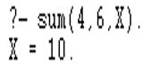

**Q2. Write a Prolog program to implement max(X, Y, M) so that M is the maximum of two numbers X and Y.**

max(X,Y,M):-X>Y,M is X.

max(X,Y,M):-Y>=X,M is Y.

OUTOUT:

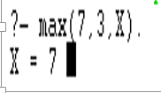

**Q3. Write a program in PROLOG to implement factorial (N, F) where F represents the factorial of a number N.**

fact(0,1).

fact(N,X):-N1 is N-1,fact(N1,Y),X is Y*N,!.

OUTPUT:

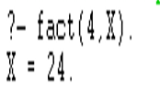

**Q4. Write a program in PROLOG to implement generate_fib(N,T) where T represents the Nth term of the fibonacci series.**

fib(1,0).

fib(2,1).

fib(N,X):- N1 is N-1,N2 is N-2,fib(N1,X1),fib(N2,X2),X is X1+X2,!.

OUTPUT:

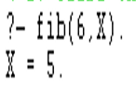

**Q5. Write a Prolog program to implement GCD of two numbers.**

gcd(0,A,A):-!.

gcd(A,0,A):-!.

gcd(A,B,R):-B1 is mod(A,B),gcd(B,B1,R).

OUTPUT:

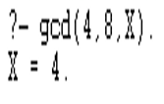

**Q6. Write a Prolog program to implement power (Num,Pow, Ans) : where Num is raised to the power Pow to get Ans.**

power(X,0):- !.

power(Num,Pow,Ans):-Ans is Num^Pow.

OUTPUT:

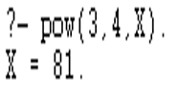

**Q7. Prolog program to implement multi (N1, N2, R) : where N1 and N2 denotes the numbers to be multiplied and R represents the result.**

multi(X,0).

multi(N1,N2,R):- R is N1*N2.

OUTPUT:

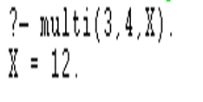

**Q8. Write a Prolog program to implement memb(X, L): to check whether X is a member of L or not.**

memb(X,[X|T]).

memb(X,[H|T]):-memb(X,T).

OUTPUT:

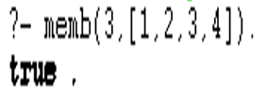

**Q9. Write a Prolog program to implement conc (L1, L2, L3) where L2 is the list to be appended with L1 to get the resulted list L3.**

conc([],L,L).

conc([X|L1],L2,[X|L3]):-conc(L1,L2,L3).

OUTPUT:

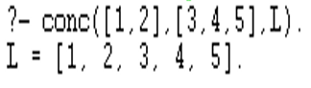

**Q10. Write a Prolog program to implement reverse (L, R) where List L is original and List R is reversed list.**

app([],L,L).

app([X|L1],L2,[X|L3]):- app(L1,L2,L3).

rev([],[]).

rev([H|T],R):- rev(T,L1),app(L1,[H],R).

OUTPUT:

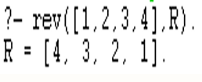

**Q11. Write a program in PROLOG to implement palindrome (L) which checks whether a list L is a palindrome or not**

app([],L,L).

app([X|L1],L2,[X|L3]):- app(L1,L2,L3).

pal([]).

pal([_]).

pal(P):-app([H|T],[H],P),pal(T).

OUTPUT:

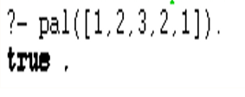

**Q12. Write a Prolog program to implement sumlist(L, S) so that S is the sum of a given list L.**

sumlist([],0).

sumlist([H|T],S):-sumlist(T,S1),S is H+S1.

OUTPUT:

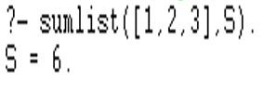

**Q13. Write a Prolog program to implement two predicates evenlength(List) and oddlength(List) so that they are true if their argument is a list of even or odd length respectively.**

evelength([]).

evelength([_|[_|List]]):-evelength(List).

oddlength([_]).

oddlength([_|[_|List]]):-oddlength(List).

OUTPUT:

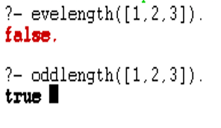

**Q14. Write a Prolog program to implement nth_element (N, L, X) where N is the desired position, L is a list and X represents the Nth element of L**

nth_element(1,[H|T],H).

nth_element(N,[H|T],X):-N1 is N-1,nth_element(N1,T,X).

OUTPUT:

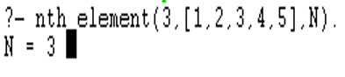

**Q15. Write a Prolog program to implement maxlist(L, M) so that M is the maximum number in the list.**

max(X,Y,Z):- X>Y,Z is X.

max(X,Y,Z):- X=<Y,Z is Y.

maxlist([],0):-!.

maxlist([R],R):-!.

maxlist([H|T],R):-maxlist(T,R1),max(H,R1,R),!.

OUTPUT:

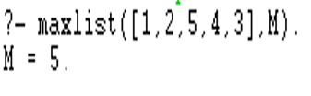

**Q16. Write a prolog program to implement insert_nth (I, N, L, R) that inserts an item I into Nth position of list L to generate a list R.**

insertn(Item,List,1,[Item|List]).

insertn(Item,[H|List],Pos,[H|Result]):-Pos1 is Pos-1,insertn(Item,List,Pos1,Result).

OUTPUT:

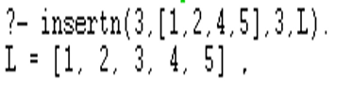

**Q17. Write a Prolog program to implement delete_nth (N, L, R) that removes the element on Nth position from a list L to generate a list R**

removen([_|List],1,List).

removen([H|List],Pos,[H|Result]):-Pos1 is Pos-1, removen(List,Pos1,Result).

OUTPUT:

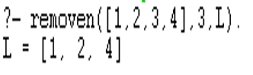

**Q18. Write a program in PROLOG to implement merge (L1, L2, L3) where L1 is first ordered list and L2 is second ordered list and L3 represents the merged list.**

merge(X,[],X).

merge([],Y,Y).

merge([X|X1],[Y|Y1],[X|Z]):-X<Y,!,merge(X1,[Y|Y1],Z).

merge([X|X1],[Y|Y1],[X,Y|Z]):-X=Y,!,merge(X1,Y1,Z).

merge([X|X1],[Y|Y1],[Y|Z]):-X>Y,!,merge([X|X1],Y1,Z).

OUTPUT:

